**Project – CloudFormation**

Stacks:

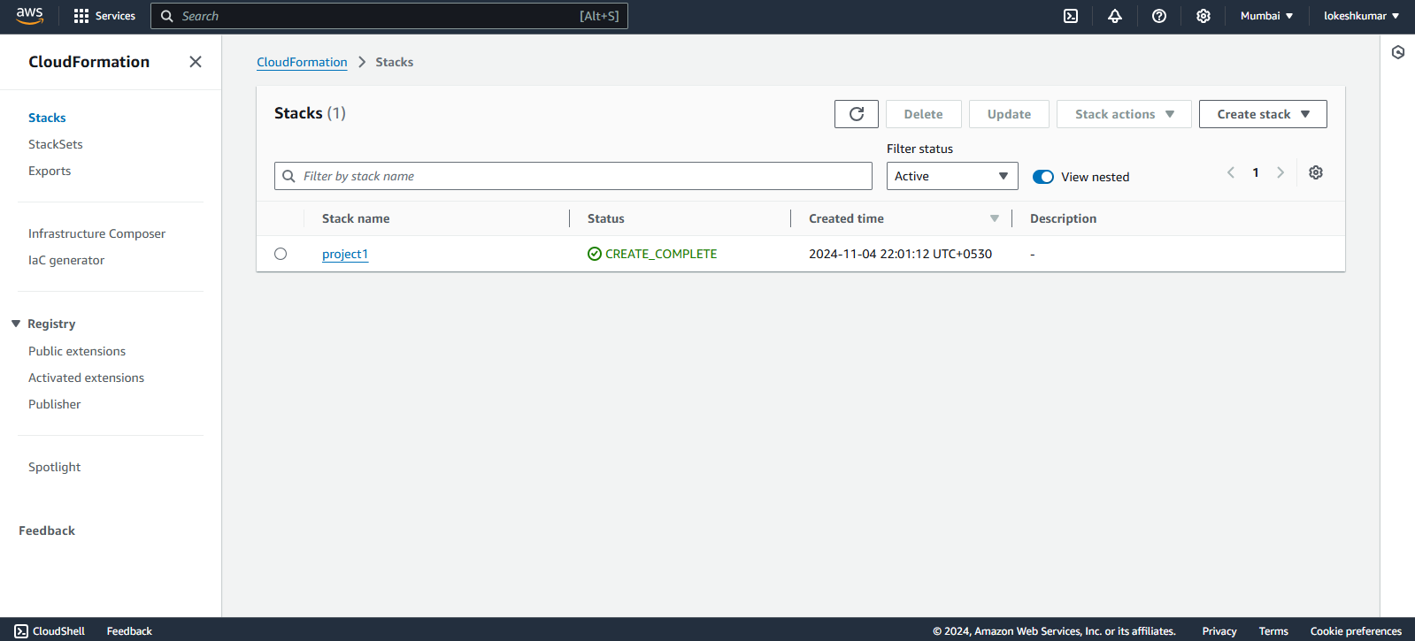

Canvas:

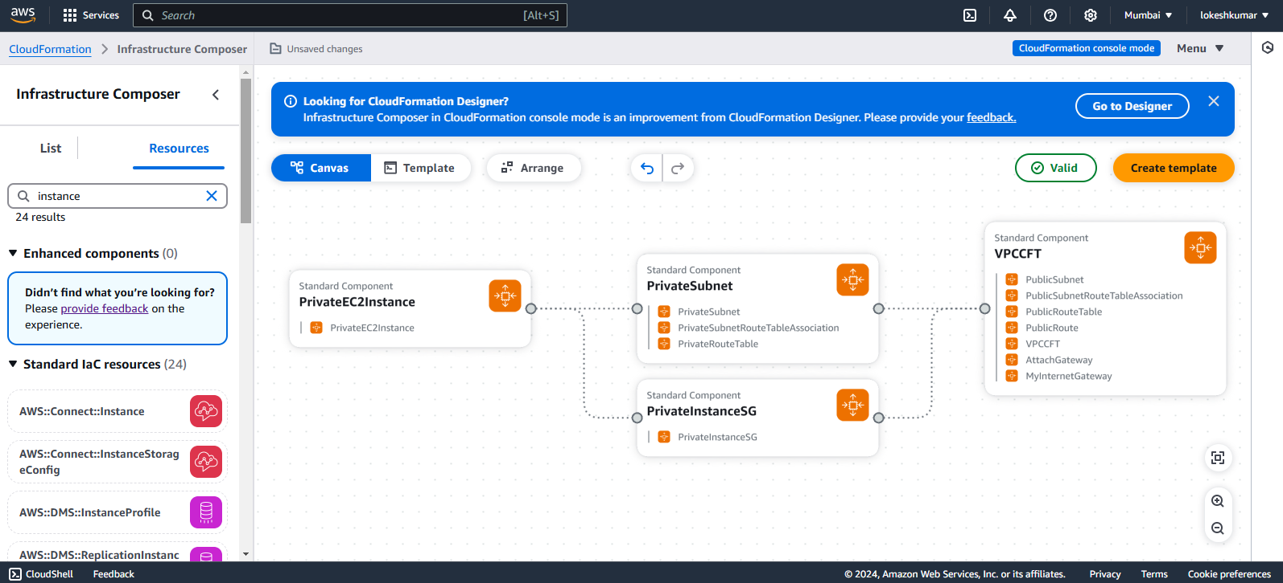

Template:

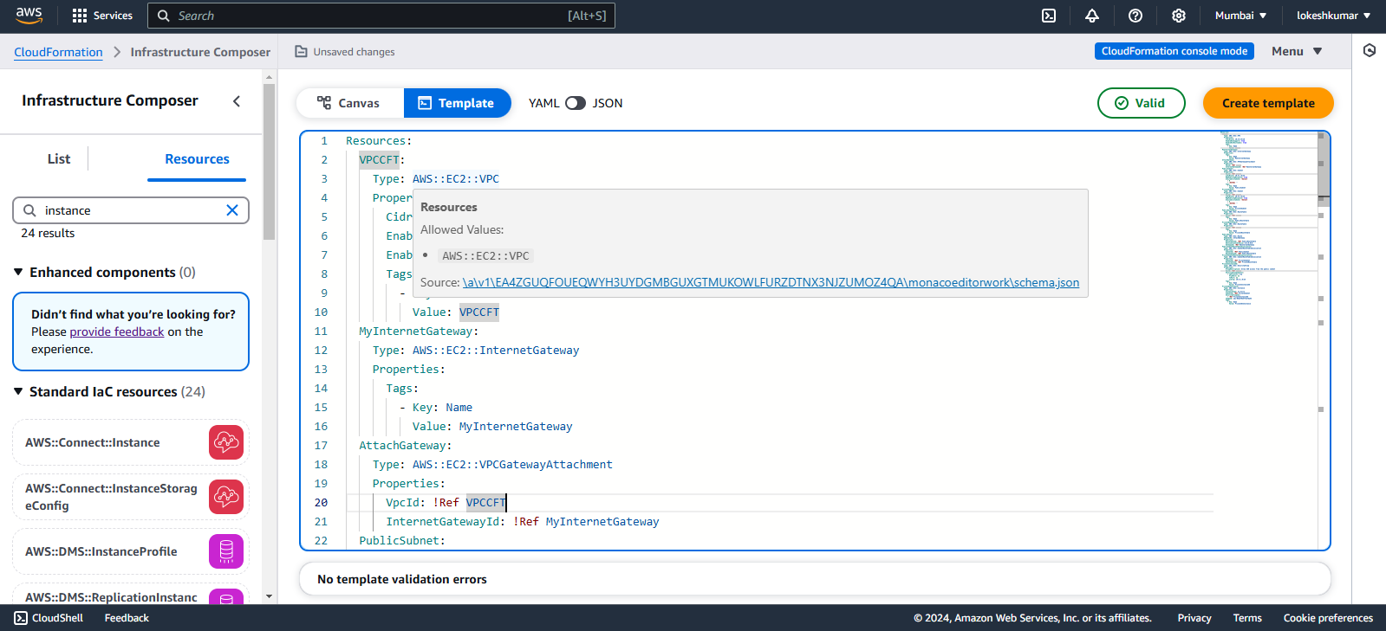

Creating a CF Template:

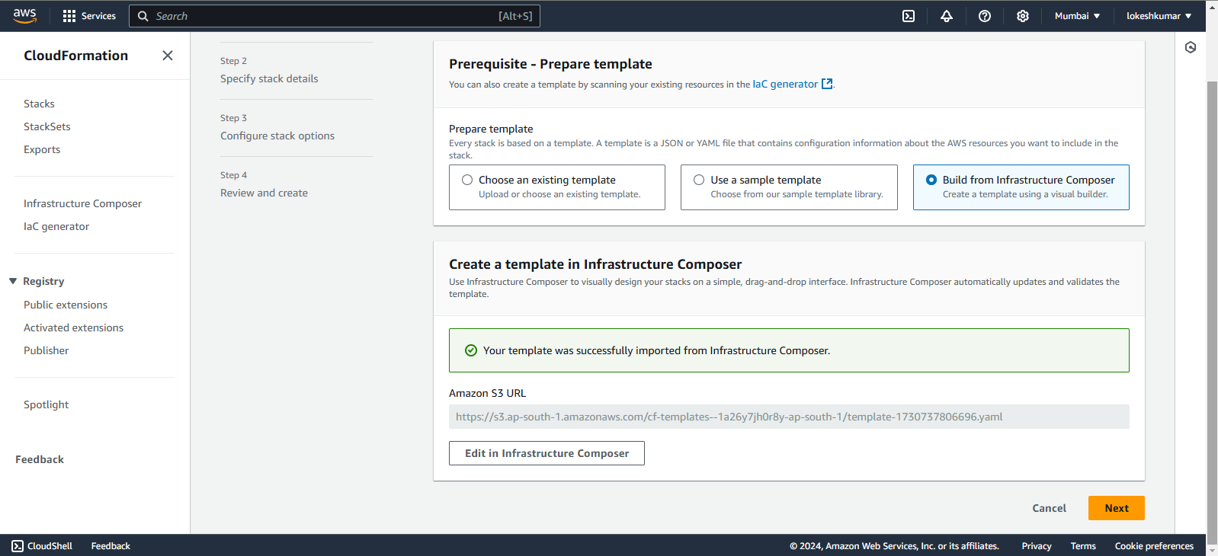

Labelling the stack:

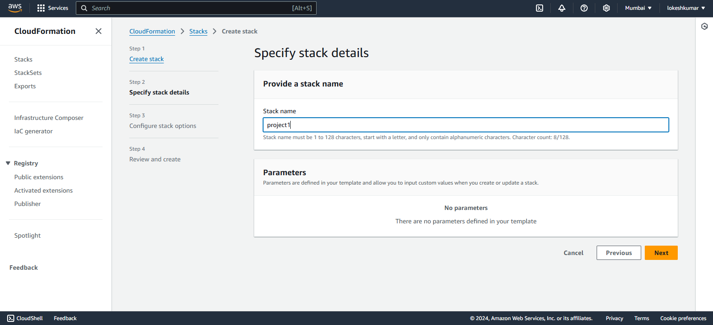

Events:

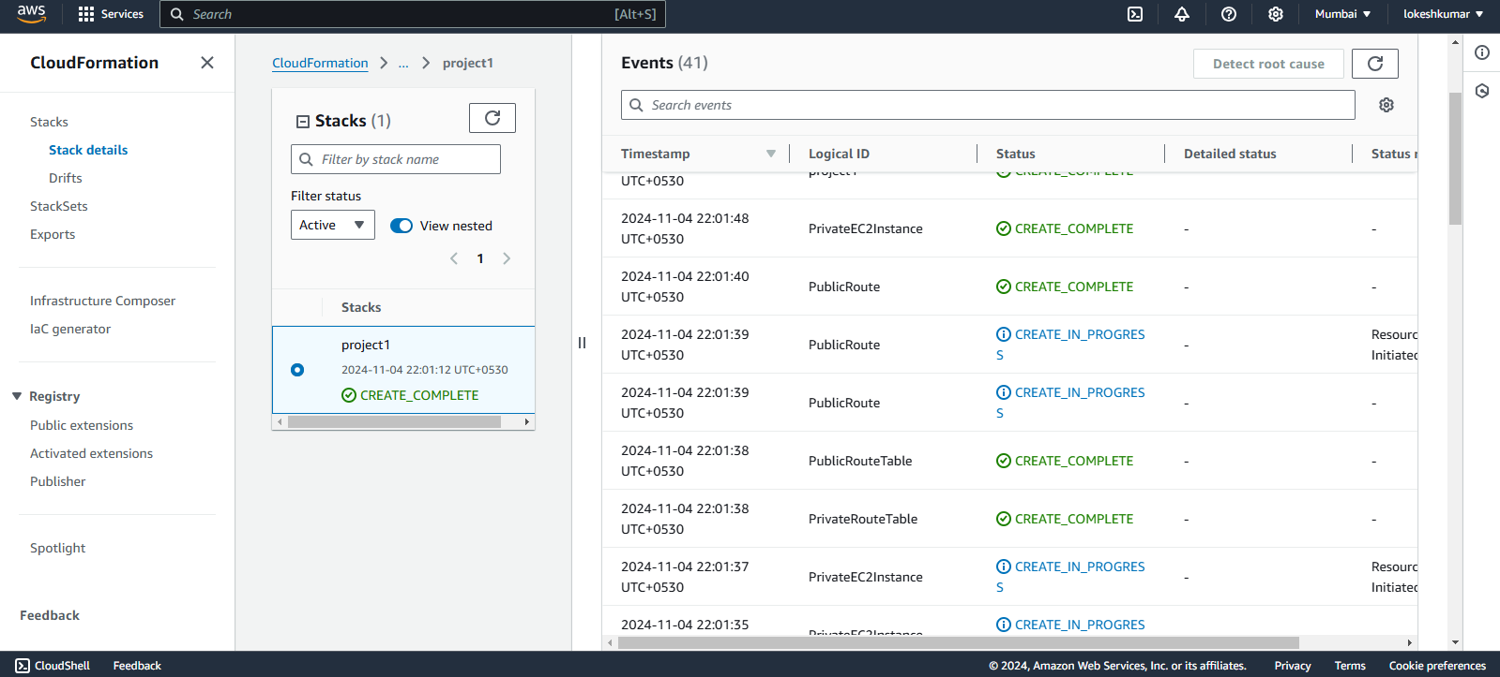

VPC Created:

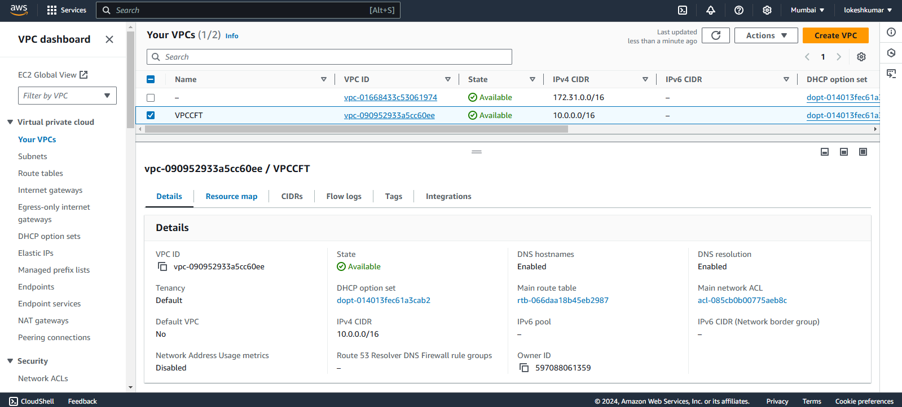

Public subnet created:

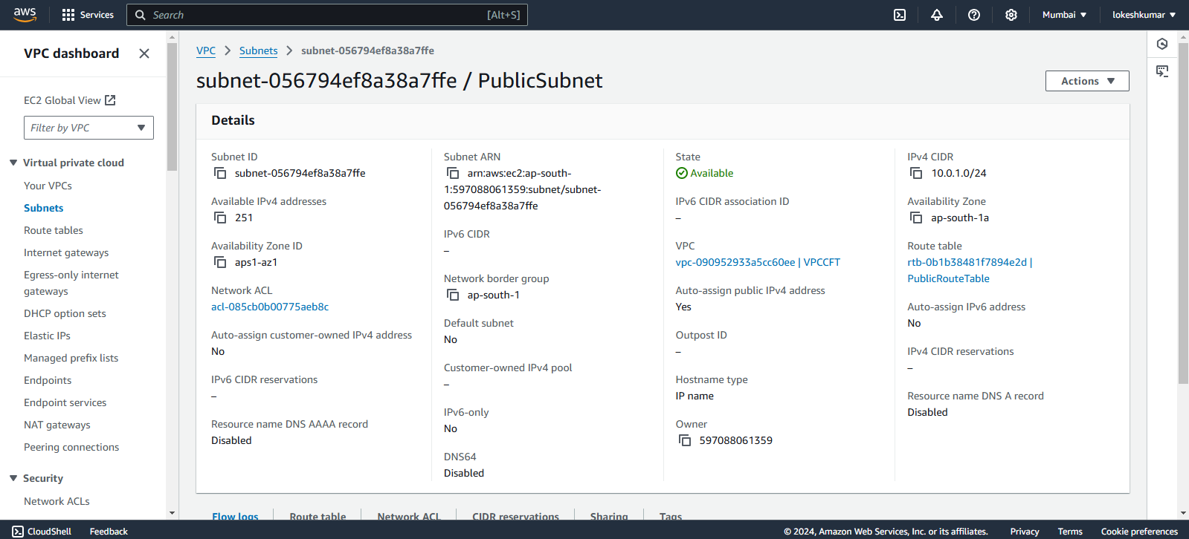

Private subnet created:

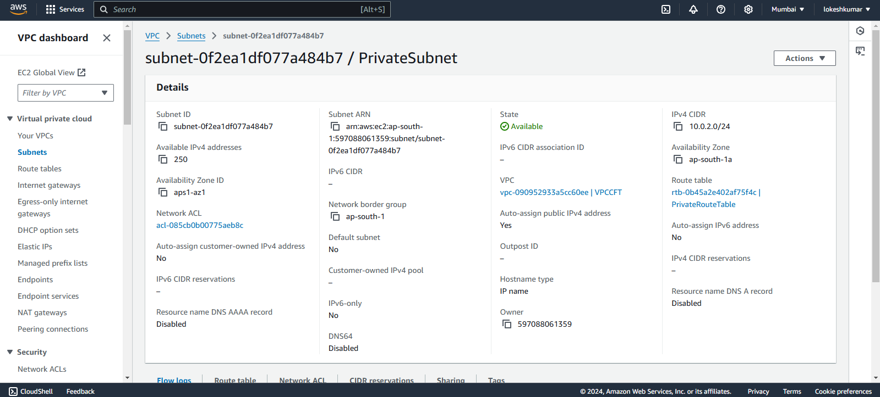

Internet Gateway created:

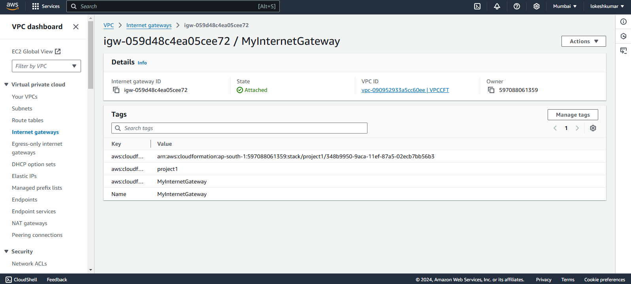

Public Route Table created:

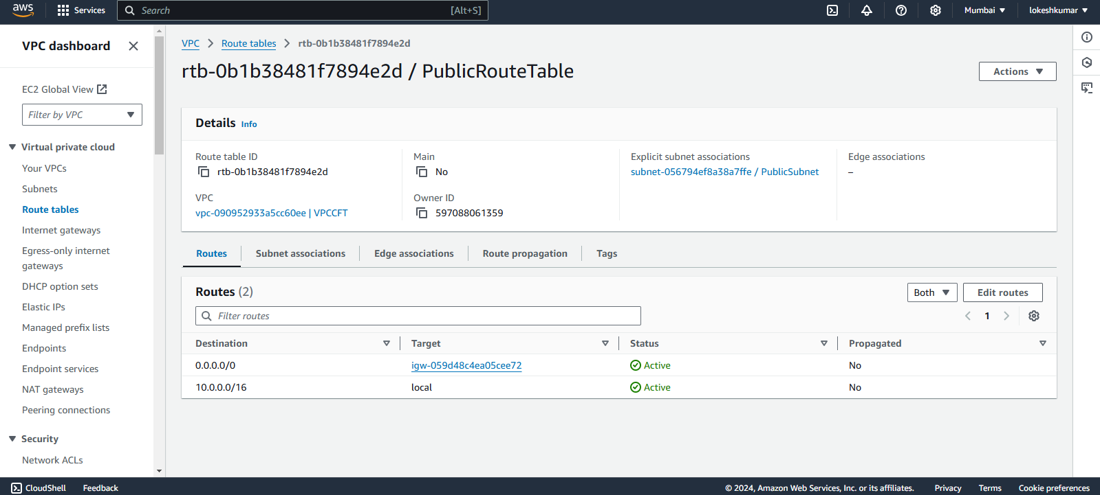

Private Route Table created:

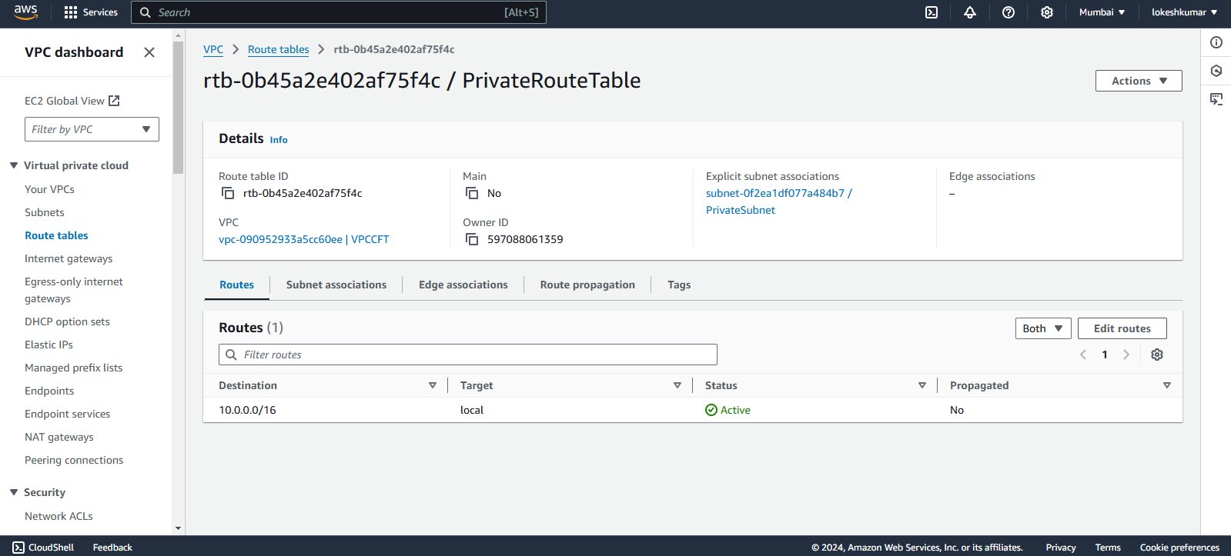

EC2 Instance created in Private subnet:

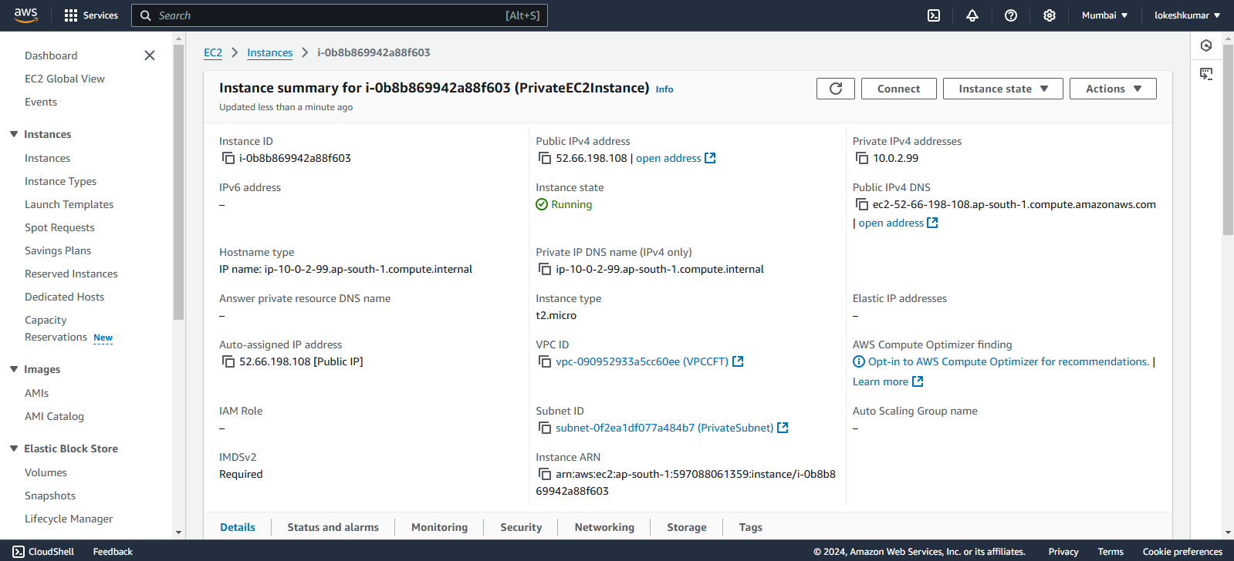

Drifts:

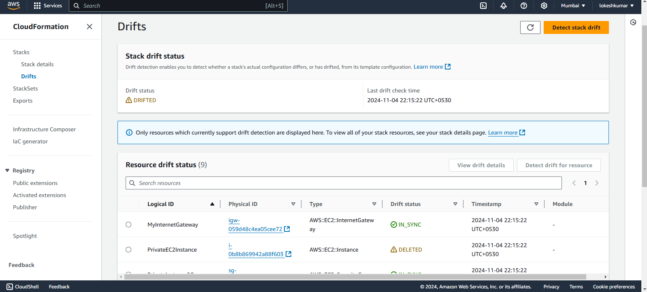

YAML CODE:

Resources:

  VPCCFT:

    Type: AWS::EC2::VPC

    Properties:

      CidrBlock: 10.0.0.0/16

      EnableDnsSupport: true

      EnableDnsHostnames: true

      Tags:

        - Key: Name

          Value: VPCCFT

  MyInternetGateway:

    Type: AWS::EC2::InternetGateway

    Properties:

      Tags:

        - Key: Name

          Value: MyInternetGateway

  AttachGateway:

    Type: AWS::EC2::VPCGatewayAttachment

    Properties:

      VpcId: !Ref VPCCFT

      InternetGatewayId: !Ref MyInternetGateway

  PublicSubnet:

    Type: AWS::EC2::Subnet

    Properties:

      VpcId: !Ref VPCCFT

      CidrBlock: 10.0.1.0/24

      MapPublicIpOnLaunch: true

      AvailabilityZone: !Select

        - 0

        - !GetAZs ''

      Tags:

        - Key: Name

          Value: PublicSubnet

  PrivateSubnet:

    Type: AWS::EC2::Subnet

    Properties:

      VpcId: !Ref VPCCFT

      CidrBlock: 10.0.2.0/24

      MapPublicIpOnLaunch: true

      AvailabilityZone: !Select

        - 0

        - !GetAZs ''

      Tags:

        - Key: Name

          Value: PrivateSubnet

  PublicRouteTable:

    Type: AWS::EC2::RouteTable

    Properties:

      VpcId: !Ref VPCCFT

      Tags:

        - Key: Name

          Value: PublicRouteTable

  PrivateRouteTable:

    Type: AWS::EC2::RouteTable

    Properties:

      VpcId: !Ref VPCCFT

      Tags:

        - Key: Name

          Value: PrivateRouteTable

  PublicRoute:

    Type: AWS::EC2::Route

    DependsOn: AttachGateway

    Properties:

      RouteTableId: !Ref PublicRouteTable

      DestinationCidrBlock: 0.0.0.0/0

      GatewayId: !Ref MyInternetGateway

  PublicSubnetRouteTableAssociation:

    Type: AWS::EC2::SubnetRouteTableAssociation

    Properties:

      SubnetId: !Ref PublicSubnet

      RouteTableId: !Ref PublicRouteTable

  PrivateSubnetRouteTableAssociation:

    Type: AWS::EC2::SubnetRouteTableAssociation

    Properties:

      SubnetId: !Ref PrivateSubnet

      RouteTableId: !Ref PrivateRouteTable

  PrivateInstanceSG:

    Type: AWS::EC2::SecurityGroup

    Properties:

      GroupDescription: Allow SSH access from the public subnet

      VpcId: !Ref VPCCFT

      SecurityGroupIngress:

        - IpProtocol: tcp

          FromPort: 22

          ToPort: 22

          CidrIp: 10.0.1.0/24

      Tags:

        - Key: Name

          Value: PrivateInstanceSG

  PrivateEC2Instance:

    Type: AWS::EC2::Instance

    Properties:

      InstanceType: t2.micro

      SubnetId: !Ref PrivateSubnet

      SecurityGroupIds:

        - !Ref PrivateInstanceSG

      ImageId: ami-04a37924ffe27da53

      Tags:

        - Key: Name

          Value: PrivateEC2Instance